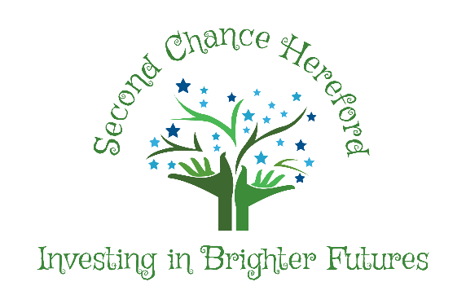
Anti Bullying Policy

Completion Date: March 2023
Review Completed Date: 20/09/23 (LC)
Review Completed Date: 22/08/2024 (VP)
Review Completed Date: 09/08/2025 (LC)
Review Completed Date: 27/08/2026 (VP)
Statement of Intent
Second Chance Hereford is committed to providing a supportive, caring and safe environment in
which all clients are free from the fear of being bullied. As an alternative provision we take bullying and its impact
seriously. Bullying of any form is not tolerated, whether carried out by a child or an adult.
Staff, clients and referring agents will be made aware of our position on bullying. Bullying behaviour is unacceptable in any form. We have high expectations of outstanding behaviour and we consistently challenge any behaviour that falls below this. Anyone who knows that bullying is happening is expected to tell a member of staff. Any young person who is a victim of bullying will be dealt with in a compassionate manner. If bullying is suspected or reported, the incident will be dealt with immediately by the member of staff informed, and then discussed with the Director. A clear account of the incident will be recorded in the incident log or for more serious incidents, on an incident report form. All staff will be informed so that close monitoring of the victim and perpetrator can begin. Where necessary, the referring agent for both parties will be informed.
What is bullying?
We recognise that many young people will experience conflict in their relationships with other young people and we are committed to developing empathy and the skills to manage relationships in a peaceful way that does not harm others.
our definition of bullying is:
“The repetitive, intentional hurting of one person or group by another person or group, where the relationship involves an imbalance of power. It can happen face to face or online”
Why is it important to respond to bullying?
There is considerable evidence to show that bullying has both short term and longer term impact on young people. Bullying impacts on wellbeing, can impact on attendance and become a significant barrier to academic and personal development. Bullying is associated with lower levels of engagement and achievement and can lead to mental health concerns such as anxiety and depression. Bullying is unacceptable. We will respond promptly and effectively to reported incidents of bullying.
In our community:
• Everybody has the right to be treated with respect.
• Everybody has the right to feel happy and safe.
• No-one deserves to be a target of bullying.
• Those who bully need to learn different ways of behaving.
National research has shown that some groups are particularly vulnerable to bullying these include young people with SEND, looked after children, those from minority ethnic groups or faiths, young carers, LGBT clients and those perceived to be LGBT.

Types of bullying behaviour
Bullying can take many forms:
• Emotional - being unfriendly, excluding, tormenting, threatening behaviour
• Verbal - name calling, sarcasm, spreading rumours, teasing, use of derogatory language
• Physical - pushing, kicking, hitting, punching or any use of violence
• Extortion - demanding money/goods with threats
• Online – use of social media, messaging and calls. Misuse of associated technology e.g photos and videos.
• Racist - racial taunts, graffiti, gestures
• Sexual - unwanted physical contact, sexually abusive comments
• Homophobic or biphobic - bullying because of sexuality or perceived sexuality
• Transphobic – because of gender identity or perceived gender identity
Preventing Bullying
We foster a clear understanding that bullying, in any form, is unacceptable. We believe that preventing bullying is the responsibility of our whole community and when there are incidents of bullying we will work together to deal with the situation and to learn from what has happened.
We do this by:
• Involving the community in developing our policy
• • Building a positive ethos based on respecting and celebrating all types of difference in our setting.
• Creating a safe and happy environment, with consequent positive relationships that have an impact on learning and achievement.
• Having a positive ethos that all who attend the setting understand.
• Think about any safeguarding concern and report concerns to Designated Safeguarding Lead.
• Provide assurances to young people that concerns have been listened to and action will be taken.
• Consider who else is involved and what roles they have taken.
• Send clear message that the bullying must stop.
• Work with both parties to find solutions. Identify the most effective way of preventing re-occurrence.
• Reflect and learn from bullying episodes –consider what needs to happen next to prevent future bullying e.g. PSHE, training etc.
• Adopting a social model approach to bullying. Diversity is valued and everyone is included
• Offering training to all staff around bullying, including specific guidance on those groups who are most likely to be bullied.
Reporting bullying
Young people are encouraged to talk to staff when they are unhappy or have concerns. They understand that they have a right to feel and be safe and a responsibility to support others to feel and be safe.
Young people are encouraged to report bullying to. When pupils report their concerns, our staff are trained to LISTEN and to BELIEVE. We involve young people as far as possible in finding solutions.
Responding to Bullying
We monitor and review all bullying incidents to determine any patterns or trends that may require further action.
All staff are required to complete a bullying and prejudice-based incident reporting and monitoring form when dealing with incidents of bullying. This should be completed as soon as possible and given to the Designated Safeguarding Lead.
All members of our community are expected to always treat everyone with dignity respect. This includes both face-to-face contact and online.

